LAB SESSION: 07
(Queue Implementation Using Linked List)

Class For Node Class For Queue
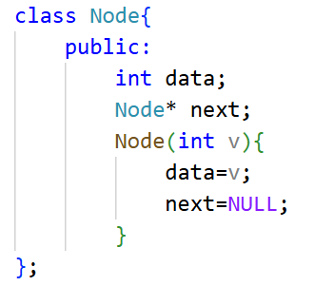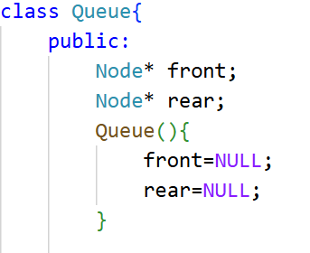

- Modify the code to take user input for enqueue and dequeue.
CODE:

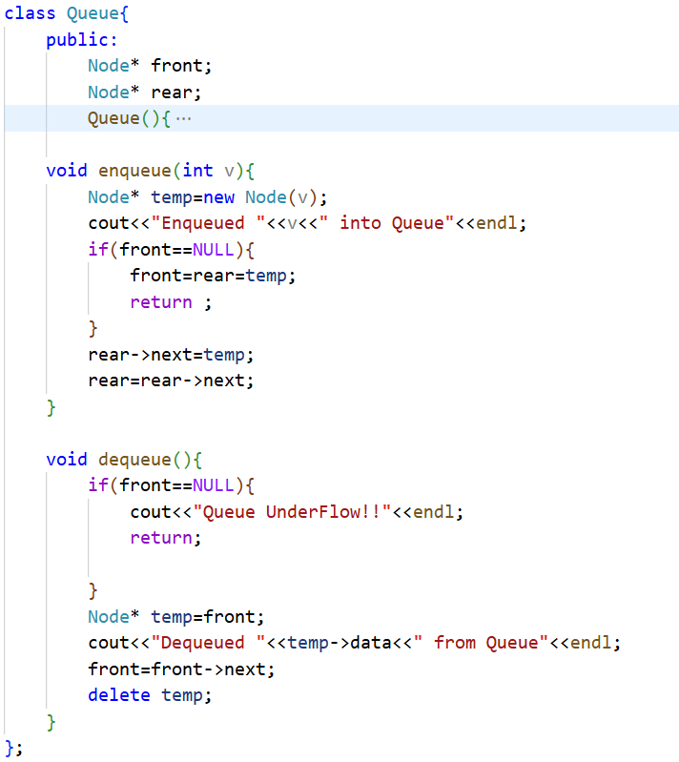
int main()
{
Queue q;
int choice, value;
while (true) {
cout << "--- Queue Menu ---"<<endl;
cout << "1. Enqueue (Add)"<<endl;
cout << "2. Dequeue (Remove)"<<endl;
cout << "3. Exit"<<endl;
cout << "Enter your choice: ";
cin >> choice;
switch (choice) {
case 1:
cout << "Enter value to enqueue: ";
cin >> value;
q.enqueue(value);
break;

case 2:
q.dequeue();
break;

case 3:
cout << "Exiting program..."<<endl;
return 0;

default:
cout << "Invalid choice! Please try again."<<endl;
}
}
}

Output:
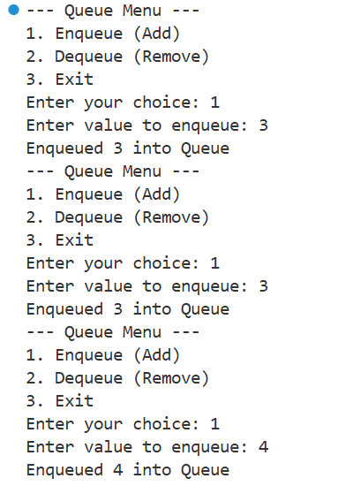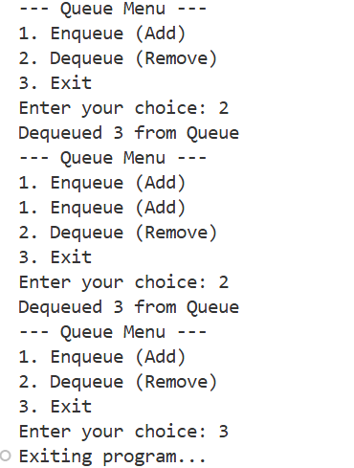
- Implement a peek() function to see the front element without removal.
CODE:
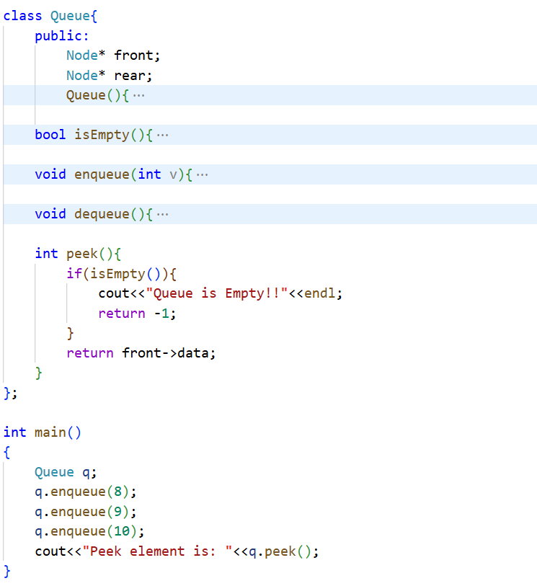}

OUTPUT:
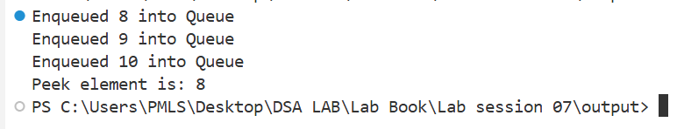
- Count and display the total number of elements in the queue.
CODE:
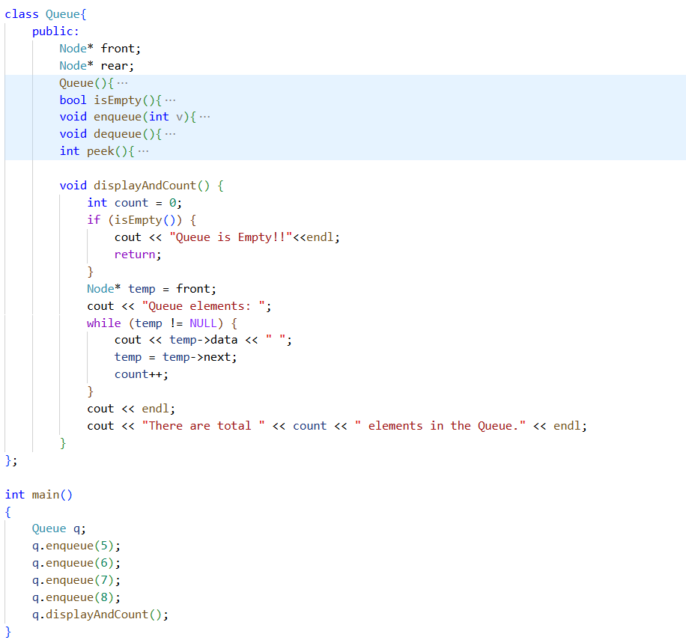

OUTPUT
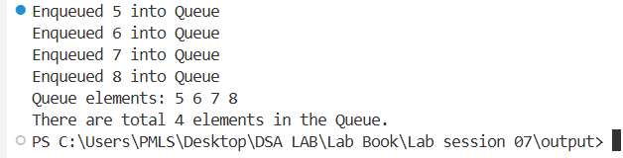
- Write a function to clear all elements in the queue.
CODE:
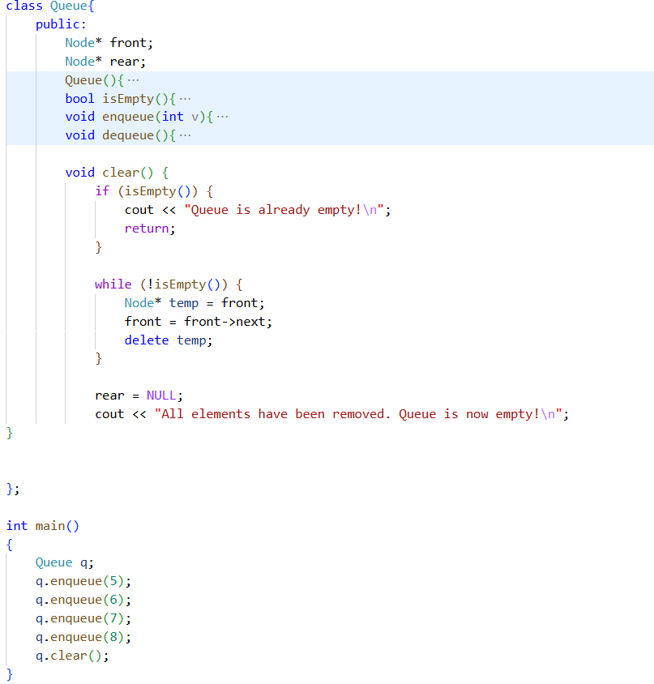

OUTPUT
